When opening an objects properties it opens with the user defined properties closed.

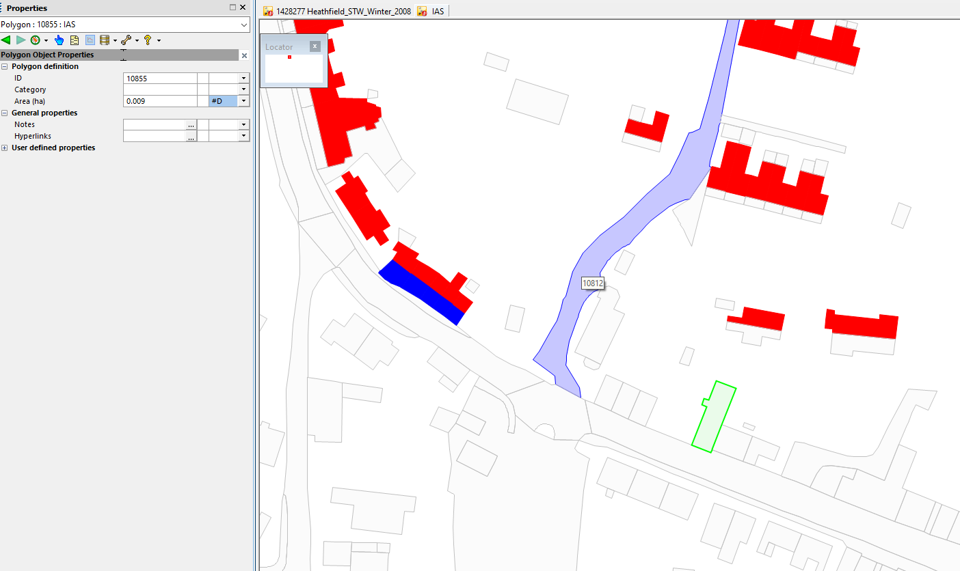

For click intensive exercises it would be very beneficial if these opened automatically or if you could toggle it on/off as required.

