# Bottom orifice :

In Wallonia, we often encounter bottom orifice as shown below (the screenshot comes from the help of SWMM). Although, there is no easy way to model this kind or bottom orifice in Infoworks.

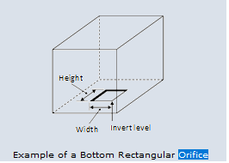

You will find below the sketch and picture of an encountered example. The bottom rectangular orifice creates a vertical drop. For higher flows, flow is split between the orifice and the pipe RV003900.

